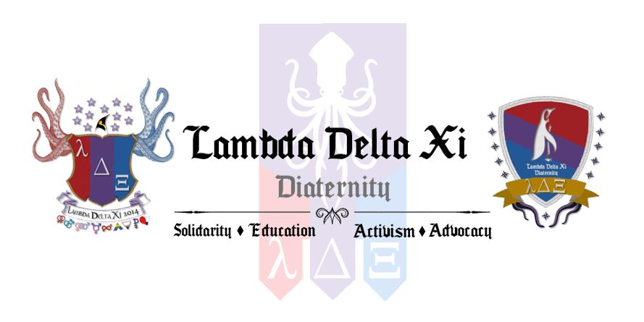

Dear Applicant,
The members of Lambda Delta Xi Diaternity, Kutztown University Chapter, are pleased to extend an invitation to you to apply for membership.
Lambda Delta Xi Diaternity, is an all-inclusive, LGBTQ and ally community focused Greek organization, founded on October 24th 2014, right here at Kutztown University. Lambda Delta Xi works to establish solidarity among members of the LGBTQ community and their allies, as well as serve the community through activism, advocacy, and education. Lambda Delta Xi is the first LGBTQ Greek organization to be established on the east coast of the United States and is currently seeking new members to continue its growth in its early stages as an active organization.
As a service organization, Lambda Delta Xi commits to community service projects, a requirement that all members must fulfill. Currently, projects are being developed by the organization for implementation in the upcoming year. These projects will be centered on both the university as well as the Borough of Kutztown. Lambda Delta Xi makes meeting the needs of its community and the LGBTQ and ally members who belong to it our top priority.
With recruitment at the forefront of our organization’s success, you are invited to complete the application attached. Those who wish to accept the invitation to apply will be invited to officially join the organization, after participating in the training sessions that are held during the semester prior to full membership. Applications can be returned to the GLBTQ Resource Center, Old Main 4 and are due March 3, 2016 at 4:00pm.
If you have any questions regarding Lambda Delta Xi, recruitment, the training sessions, or any other concern, please feel free to contact me at LambdaDeltaXI@kutztown.edu. We look forward from hearing back and hope you consider joining our organization.
In Solidarity,

[Chapter Name]

[Chapter Name]
Lambda Delta Xi Diaternity

Requirements of Membership
Thank you for applying to become a member of Lambda Delta Xi Diaternity. We encourage you to review the requirements of membership which are listed below.
- Be in good academic and disciplinary standing maintain a grade point average of a 2.5 or higher each semester.
- Have completed all required Training Seminars during their Prospective Membership status.
- Be trained as a Safe Space Advocate, which is completed through the Training Seminars.
- Commit to a minimum of 3 community service hours each semester.
- Attend required Lambda Delta Xi meetings and events.
- Pay the yearly Student Activity Fee and/or other dues if applicable.
- Uphold the principles of Solidarity, Education, Activism, and Advocacy.

Personal Information
Preferred Pronouns

Preferred Name

Major(s) and Minor(s)

Estimated Year of Graduation

Phone Number

Kutztown University Email

GPA (2.5 or Higher)

Questions
Why do you want to join Lambda Delta Xi Diaternity?
Have you ever been involved with the queer community?
Yes No Unsure
What previous involvement have you had that would make you a good candidate for membership?

If yes, what were you involved with? If leadership positions were held please list them and what you did.

What other organizations and campus activities are you involved with currently? If leadership positions are held please list them.

In what ways have you been an ally for the queer community?

Agreements and Conditions
Signature
________________________
Date
________________________
I Agree
I Agree
I Agree
I Agree
By selecting I agree, you pledge to uphold the anti-hazing policy set forth by this organization.
By selecting I agree, you understand that you are required to commit to a minimum of 3 community service hours each semester.
By selecting I agree, you confirm that you will participate in the Training Seminars prior to your full membership and that failure to attend the seminars could result in termination of Prospective Membership Status.
By selecting I agree, you confirm that you are a student enrolled at Kutztown University.

